Fixed wing drone stabilization system

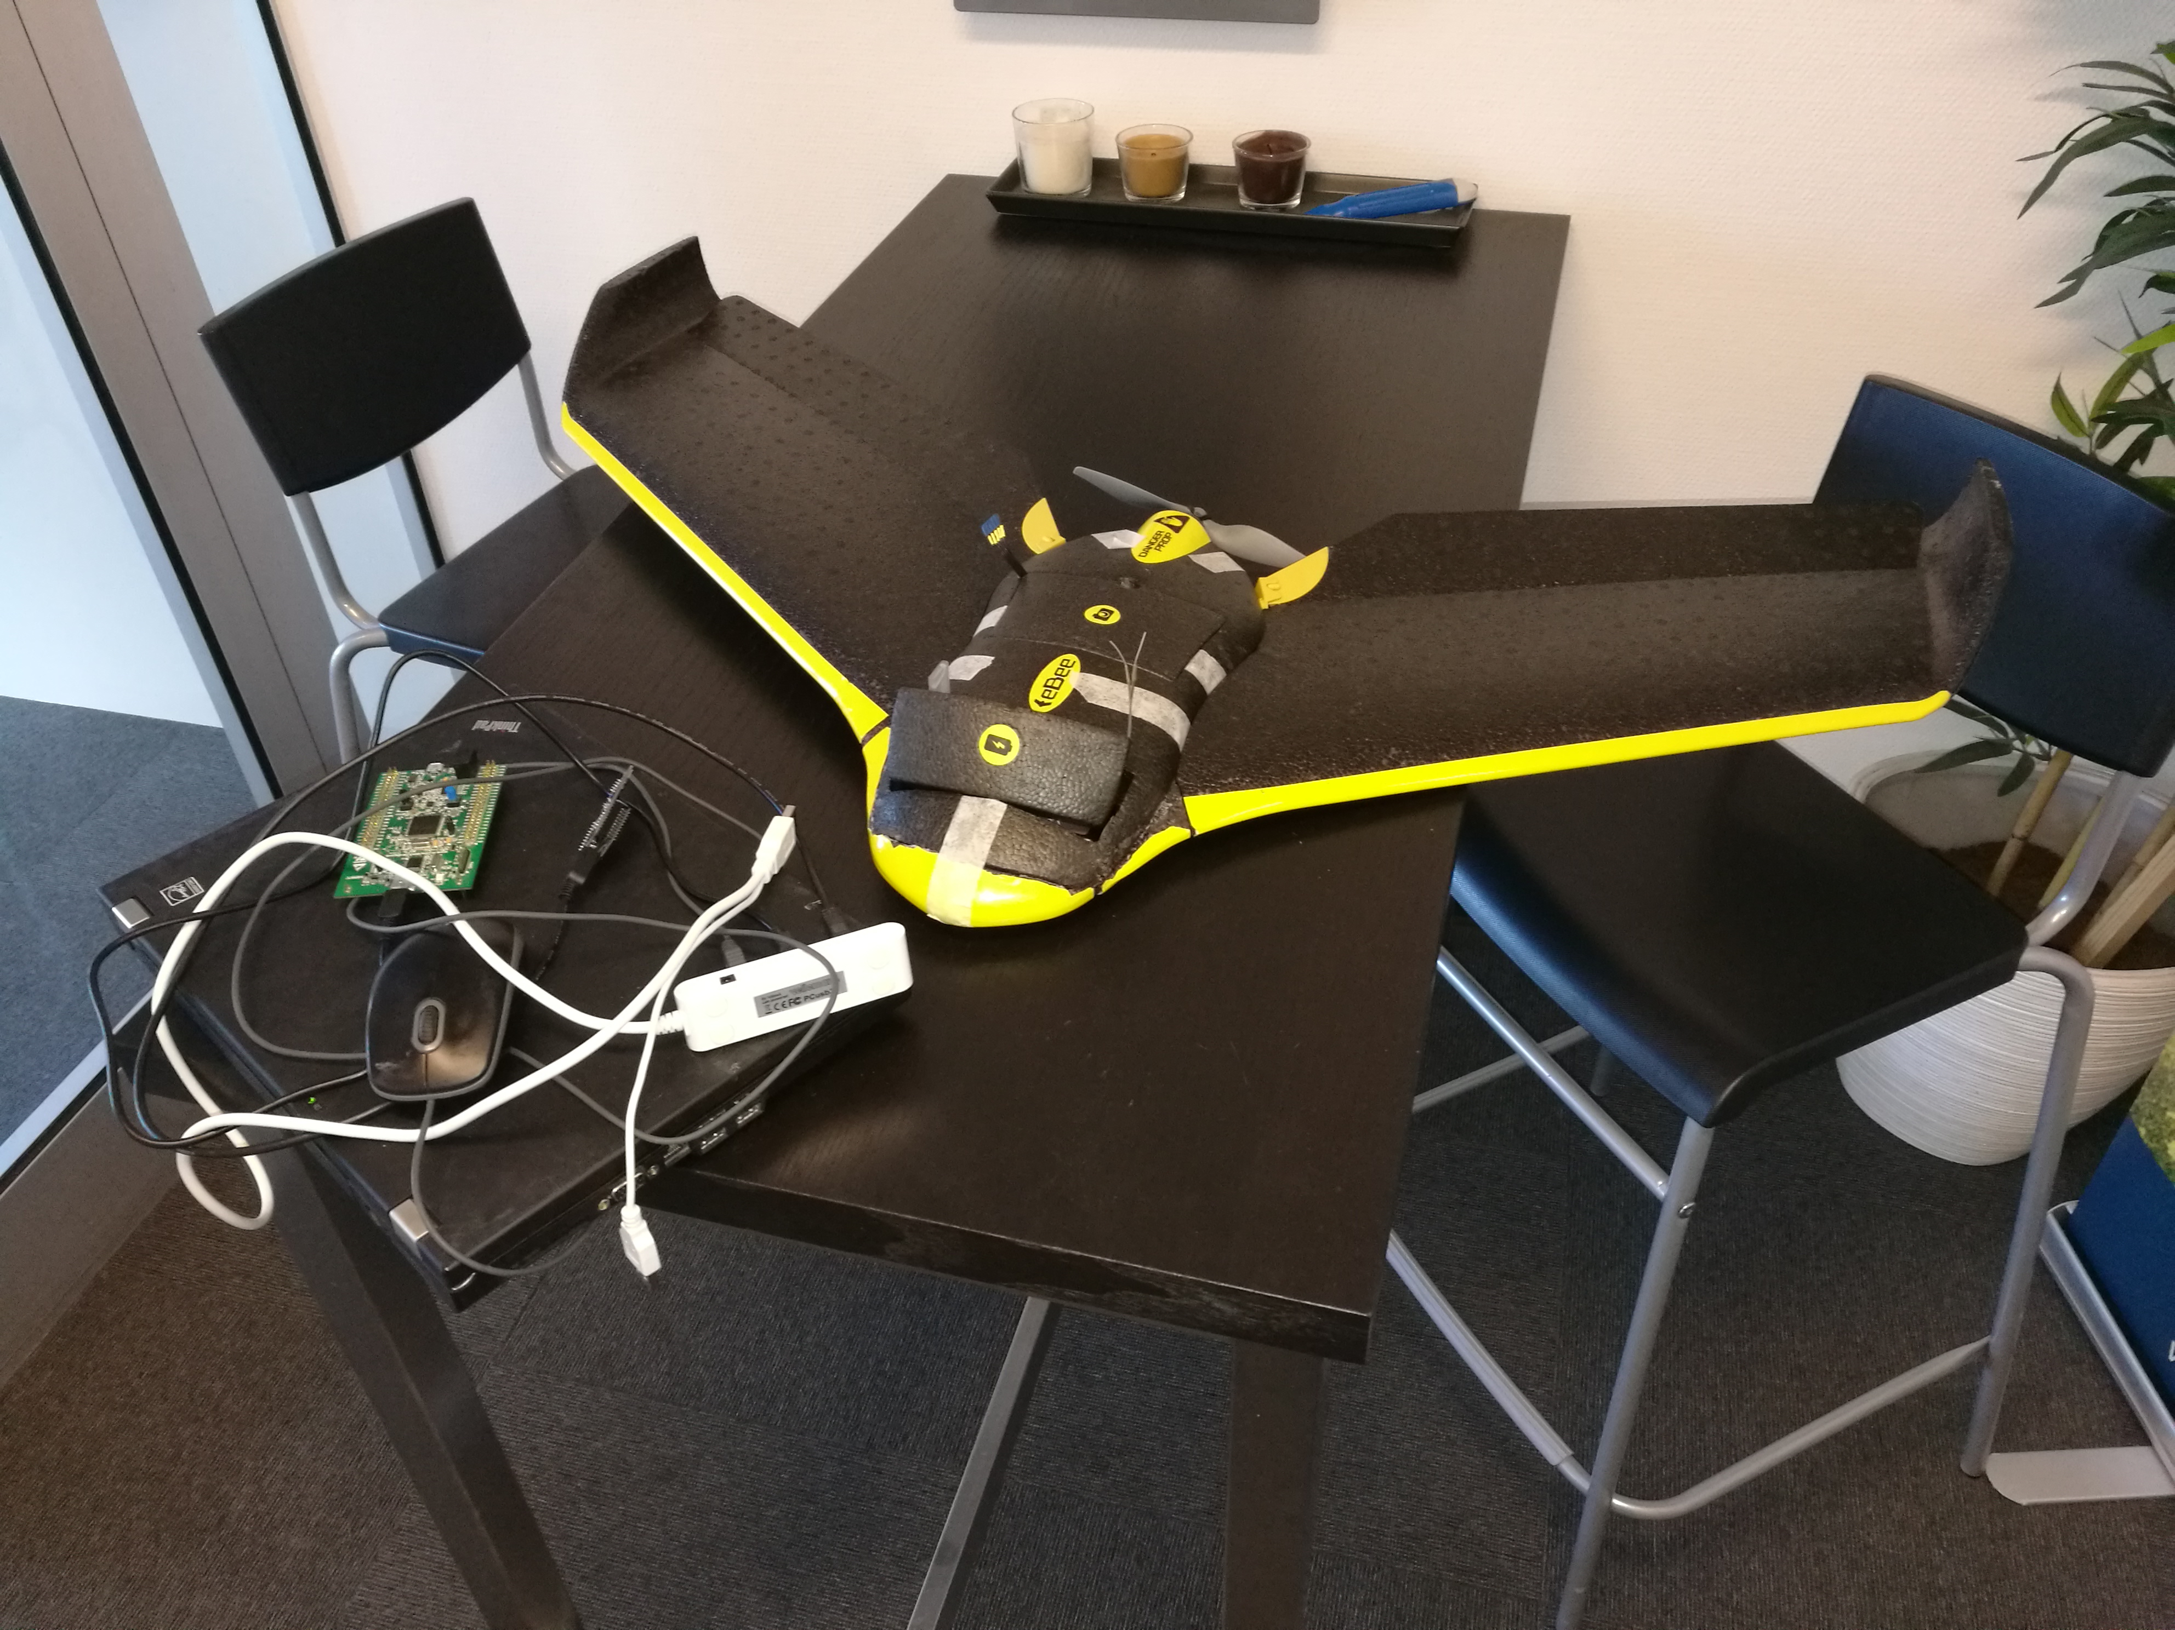

Fixed wing drone stabilization system

______________________________________

Miroslav Lakota 1.6.2018

# Synopsis

# 

**Tabl****e of Contents**

Synopsis 3

Preface 5

Introduction 6

Problem formulation and project scope 7

The Project 8

Conclusion 9

List of references 10

Bibliography 11

Appendices 12

# Preface

# Introduction

# Problem formulation and project scope

# The Project

## 

# Conclusion

# List of references

# Bibliography

# Appendices